neo MOTLOUNG, ST10538987, LECTURE: LWAZI, WEDE5020
BAKED WITH LOVE, SHARED WITH JOY
30 March 2026
SWEET CRUMBS BAKERY
54Nota street Phake section
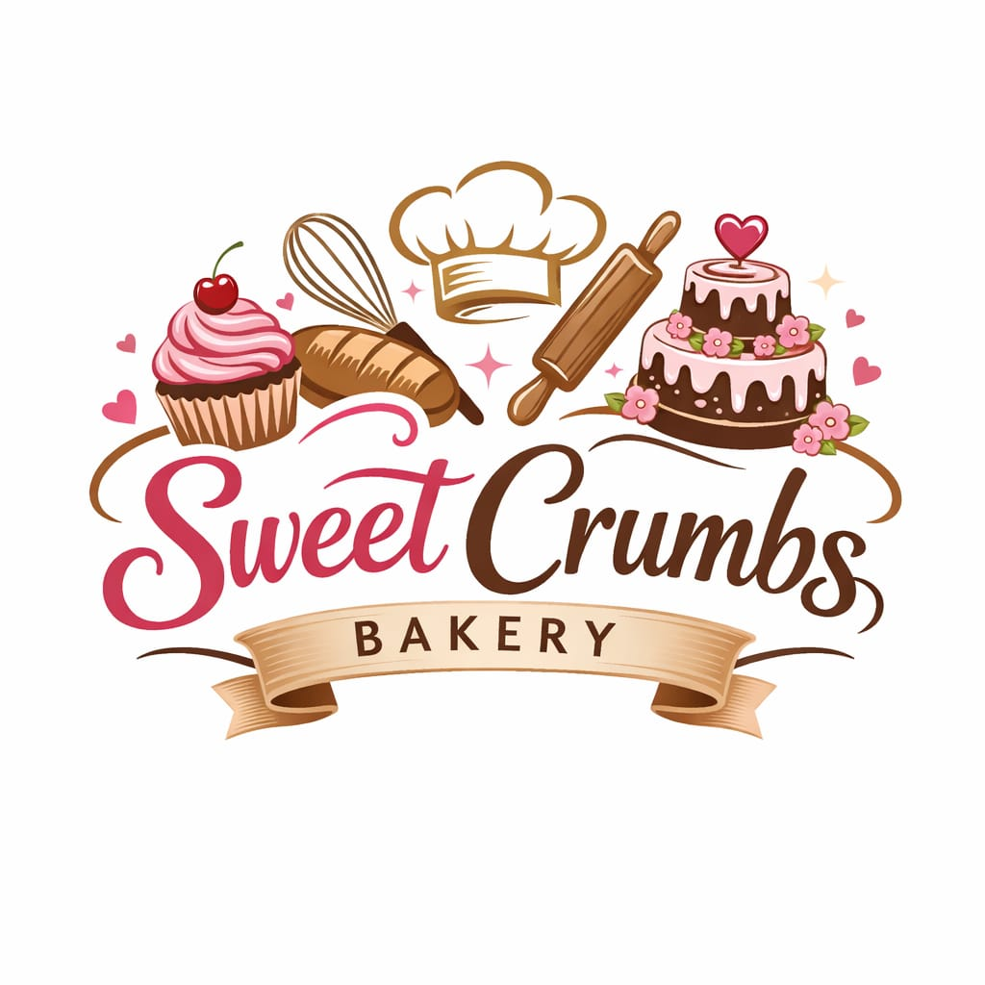

Contents
1. Organization Overview 1
2. Website Goals and Objectives 1
2. Website Goals and Objectives 2
3. Current Website Analysis 2
4. Proposed Features and Functionality 2
5. Design and User Experience 3
6. Technical Requirements 3
7. Timeline and Milestones 4
8. Budget Estimate 4
9. References 4

1. Organization Overview
Name: Sweet Crumbs Bakery
Sweet Crumbs Bakery is a small local business that makes fresh cakes, pastries, and bread. I wanted to help the community by making high quality baked goods using traditional methods of baking. Over time, word of mouth made my business popular, and I now have loyal customers
Mission: To bake fresh and delicious baked cakes, pastries and bread while giving customers great service.
Vision: To be known as a bakery that is creative and consistent and makes good food
Target Audience:
- People from the area
- families
- students
- people planning events (birthdays, weddings)
- walk-in and online customers

2. Website Goals and Objectives
- Goals:
• Create an online presence for the bakery
• Share important business and contact information
• Show products and services
• Attract new customers
• Promote special offers and events
- Key Performance Indicators (KPIs):
• More people visiting the website
• An increase in participation in social media
• A rise in sales and orders from customers

3. Current Website Analysis
Sweet Crumbs Bakery does not have a website yet
- Opportunities:
• Create a professional digital presence
• Make it easier for customers to find and contact the business
• Reach more people beyond the local community

4. Proposed Features and Functionality
- Pages:
• Home Page
• About Us
• Products/Services
• Gallery
• Contact Page
• Order/Enquiry Form
- Features:
• Works well on phones and computers
• Easy to use and navigate
• Contact form for customer enquiries
• Links to social media platforms
• Business location and operating hours

5. Design and User Experience
- Design Style:
• Clean and modern layout
• Warm and welcoming look
- Color Scheme:
• Cream
• Soft pink
• Light brown
- Typography:
• Simple, easy to read fonts
• Stylish headings
- User Experience:
• Easy to move between pages
• Fast loading
• Clear buttons (like “Order Now)

6. Technical Requirements
- Hardware Requirements:
• Computer or laptop for development
• Smartphone for testing the website on mobile devices
- Software Requirements:
• Web browser (Google Chrome, Microsoft Edge)
• Code editor (Visual Studio Code)
• Design tools (Canva or Figma)
- Technologies Used:
• HTML for structure
• CSS for styling
• JavaScript for interactivity
- Hosting Requirements:
• Web hosting service

7. Timeline and Milestones
- Week 1: Research and approval
- Week 2: Content collection (images, text)
- Week 3: Website Design
- Week 4: Website Development
- Week 5: Test and improve the website
- Week 6: Final Submission

8. Budget Estimate
- Domain name: R10–R5 per year
- Web Hosting: R50–R100 per year
- Design Tools: Free or up to R10
- Development Cost: R0 .00(student project)
- Total Estimated Cost: R60-R125

9. References
- W3Schools. (2024).HTML, CSS, and JavaScript Tutorials.
- MDN Web Docs (2024), Web Development Resources.
- Canva (2024). Design Resources.
- Google Fonts. (2024). Free Fonts Library.

